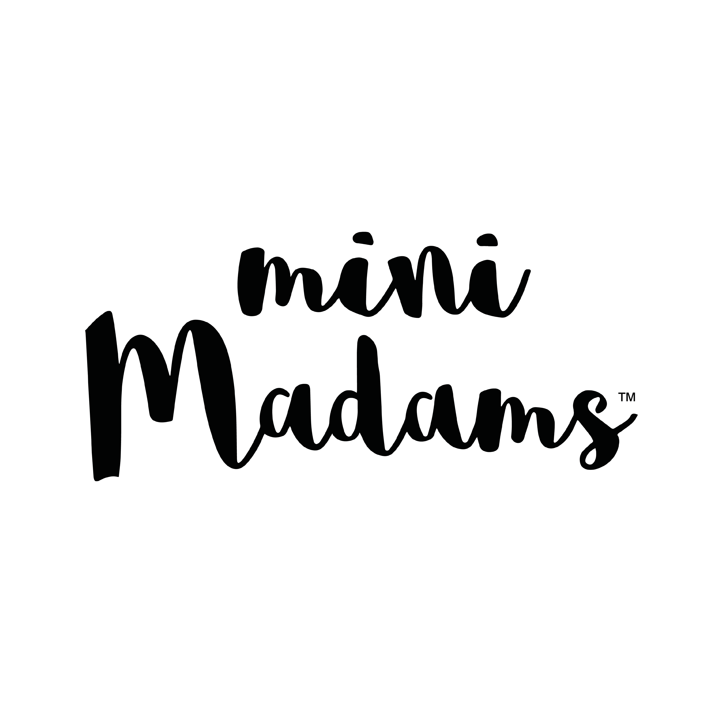
Consent form for filming / photography child under 18 years of age
Child’s Name……………………………………………………………….. Age……………………………………………..
Parent/Guardian’s Name …………………………………………………
I hereby consent to Mini Madams using images of my above named child caught in video recordings, and/or photographs on …………………………………………………………………..[insert date] at………..…………………………………………………………………………… [insert location] For use in………………..……………………………………………………………………………..
[insert details]
[I also consent to them being used for other marketing and publicity-related purposes such as our various social media channels] and I understand that they may be published on the Mini Madams website or another website or elsewhere.]
I understand that:
- their images will be held in accordance with the Data Protection Act;
- that the images of my child captured in the video recordings and/or photographs will be the copyright of Mini Madams and any other intellectual property which arises in the recordings will also belong to Mini Madams;
- My child and I hereby agree to irrevocably assign all property rights in my child’s performance and/or recordings to Mini Madams;
- My child and I hereby agree to waive all moral rights in my performance in the film and/or recordings to Mini Madams.
- I can ask Mini Madams to stop using my child’s images at any time, in which case they will not be used in future publications but may continue to appear in publications already in circulation

Signed by Parent………….…………………………………………………..

Date……………………………………….

Address…………………………………………………………………………………………………

Signed by child…………………………………………………………………………………………

